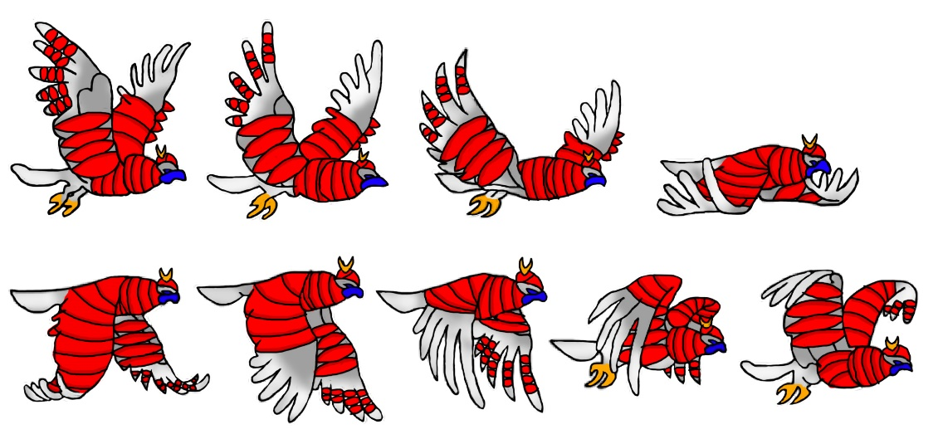
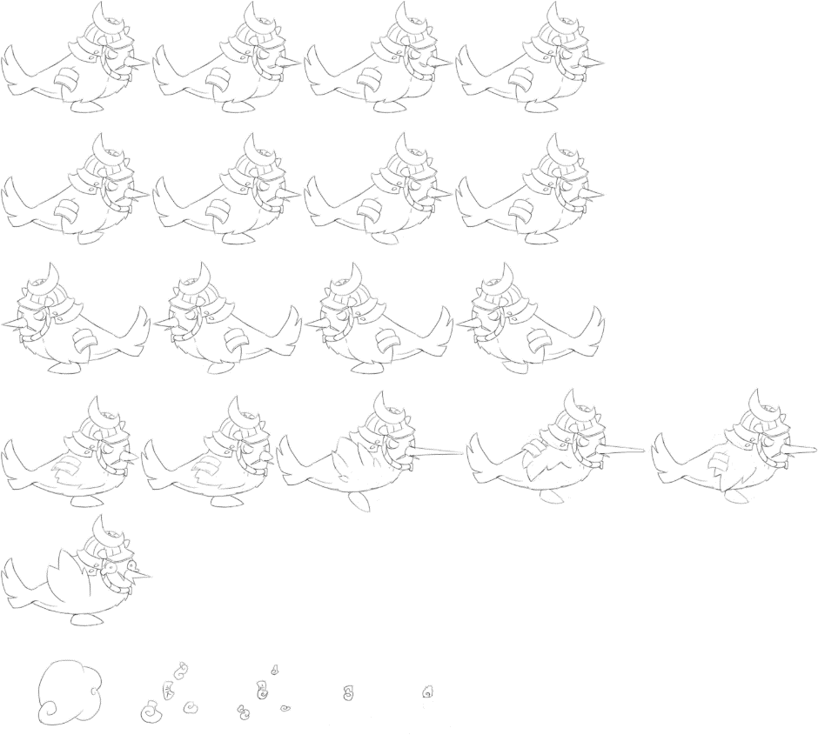
The enemy Samurai birds serve as the guards of the Japanese shogun castle, safeguarding the palace from any intruders sneaking about. These birds are the Spider shoguns Shikigami which fly around platforms which the player must avoid or risk being kicked out if seen by the enemy, starting from the beginning or last save point.
We originally were going with the latter sprite sheet but due to difficult circumstances of inconsistency in art, we decided to go with a more realistic approach.

